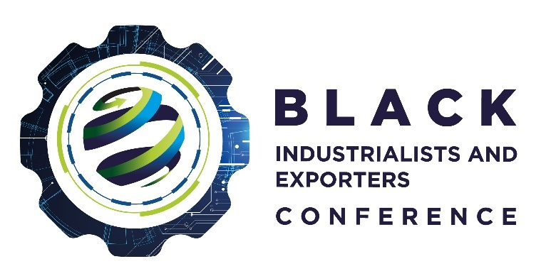
Innovation and Technology Award
This award recognises all companies who have made use of technology in innovative and different ways or who has designed new innovative technology. A company who has demonstrated exceptional technical excellence for the sector or the South African economy.
All companies who have been approved and benefited from financial schemes offered by government and its entities are invited to enter in the applicable categories.

Requirements | Provide details/ confirmation
- Name of Company/Organisation
- Company Registration Number and Business Address
- Company Tax Number (Confirm)
- VAT Number (Confirm)
- Owners/Directors of the Company (List including Race, ID Numbers of owners and percentage of each director)
- BEE Status (Confirm)
- Incentive Scheme/ Programme (approved, benefited and support received from the dtic, IDC, ECIC and NEF)
- Areas to motivate
  - Skills Development
  - Jobs Created
  - Revenue Growth since supported
- Innovation and Technology
9.1 Type of innovation and technology developed and used
9.2 Ownership of patent/ intellectual property for the technology used
9.3 How the technology used has improved the products or services offered?

I have read and agree to abide by the rules and regulations as stipulated in the criteria, entry rules, terms, and conditions for the 2022 Black Industrialists and Exporters Awards. I declare that all the information supplied on behalf of and for participation in these awards is true and correct.
Name and Surname:
Designation:
Signature:
Date:

