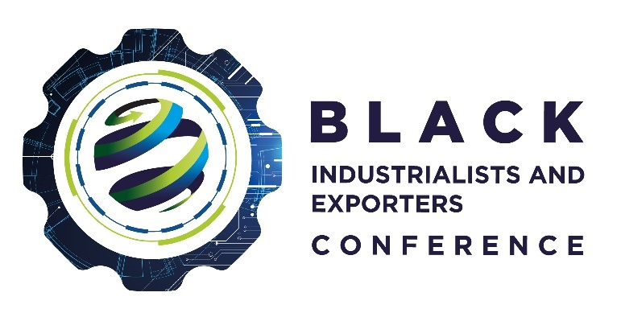
Sustainability Award (Green Industries and Greening the Economy)
This award recognises all green industries and business, which are in greening the economy, driving products and services seeking sustainability and sustainable environments. It aims to encourage South African companies to participate in industries using natural resources to prevent carbon emissions, climate change and ensure environmental conservation. The nominees must show a solid track record of trading in green industries for the last three fiscal years. We are looking for companies who are contributing to the sustainability and climate change agenda in terms of low carbon production, renewable energy generation and/or development of cleantech solutions in the waste, water, green transport, sustainable agriculture or energy sectors. Companies who have demonstrated exceptional technical excellence for the green economy are welcomed to apply.

Requirements | Provide details/ confirmation
- Name of Company/Organisation
- Company Registration Number and Business Address
- Company Tax Number (Confirm)
- VAT Number (Confirm)
- Owners/Directors of the Company (List including Race, ID Numbers of owners and percentage of each director)
- BEE Status (Confirm)
- Incentive Scheme/ Programme (approved, benefited and support received from the dtic, IDC, ECIC and NEF)
- Areas to motivate
  - Skills Development
  - Jobs Created
  - Revenue Growth since supported
- Green Industries
9.1 Number of Years in Green Industries
9.2 Type of products and services
9.3 Innovation
I have read and agree to abide by the rules and regulations as stipulated in the criteria, entry rules, terms, and conditions for the 2022 Black Industrialists and Exporters Awards. I declare that all the information supplied on behalf of and for participation in these awards is true and correct.
Name and Surname:
Designation:
Signature:
Date:

