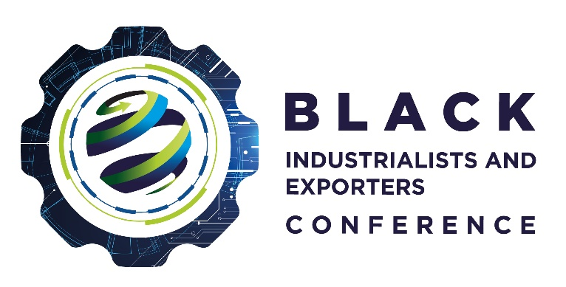
Women Black Industrialist Award
This award recognises women owned companies trading in South Africa and women who demonstrate high levels of entrepreneurship. The company should be at least 51% black women owned and be in the services or manufacturing sectors. The company owner must demonstrate leadership potential. In addition, the company must be able to demonstrate evidence and measures to create jobs, skills transfer and revenue growth.

Requirements | Provide details/ confirmation
- Name of Company/Organisation
- Company Registration Number and Business Address
- Company Tax Number (Confirm)
- VAT Number (Confirm)
- Owners/Directors of the Company (List including Race, ID Numbers of owners and percentage of each director)
- BEE Status (Confirm)
- Incentive Scheme/ Programme (approved, benefited and support received from the dtic, IDC, ECIC and NEF)
- Areas to motivate
  - Skills Development
  - Jobs Created
  - Revenue Growth since supported

I have read and agree to abide by the rules and regulations as stipulated in the criteria, entry rules, terms, and conditions for the 2022 Black Industrialists and Exporters Awards. I declare that all the information supplied on behalf of and for participation in these awards is true and correct.
Name and Surname:
Designation:
Signature:
Date:

