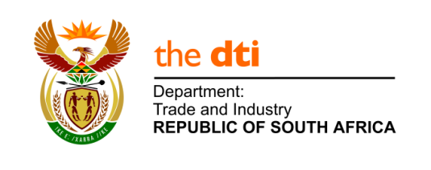

TRADE ENQUIRY FORM

Date Received | 17 December 2020 | Date Completed
Allocated to |  | Reference Number
FOREIGN OFFICE
Office Contact Details and Contact Person:
Mr. Vladislav Krivosheev
Marketing Officer
The DTIC office in Moscow
Embassy of the Republic of South Africa in Russia
vladislav@thedti.ru

COMPANY CONTACT DETAILS
Company/Organisation Name: B2B-Export Limited
Type of business (please tick one): | Manufacturer | Importer | Distributor | Wholesaler |  | Retailer | Agent | Other (please state):  Platform for importers
Contact Person: Anastasia |  |  |  |  | Designation: Supply chain manager
Address: Moscow
Telephone: +7 916 866 30 58
Facsimile:
E-Mail: procurement@b2b-export.com
Website: b2b-export.com

PRODUCT
Product Required: cherry fresh
Type (colour, size etc.): L, XL
Quality (grade, ISO etc.): 1 grade, quality according to standards FFV of UNECE
HS Code: 0811908000

QUANTITY
Quantity Required (units, volume, container etc.): several pallets

DELIVERY
When is the product required: next season 2021
How frequently is the product required: every week
Destination Port: Moscow airport

FOR FER USE:
How did you acquire this enquiry: (please tick one) | Face-to-face meeting | Email | Telephone | Site Visit | Trade Show | Other (please state):
Further notes:

Please ensure that all the fields are filled in
NB. The information in this form is shared with South African companies
Email to: tradeleadbulletin@thedti.gov.za
Thank you

